**Project Based Learning Report**

on

**Implementing game playing using Adversarial Search Algorithms with Minimax and Alpha-Beta Pruning in Python**

Submitted in the partial fulfillment of the requirements

For the Project based learning in **Artificial Intelligence and Data Mining**

in

Electronics & Communication Engineering

By

**PRN Name of the Student**

**2014111054 Ekakshar Joshi**

**2014111072 Nishal Kumar**

Under the guidance of Course In-charge

Dr. Tanuja S. Dhope

Department of Electronics & Communication Engineering

Bharati Vidyapeeth

(Deemed to be University)

College of Engineering,

Pune – 4110043

**Academic Year: 2023-24**

**Bharati Vidyapeeth**

**(Deemed to be University)**

**College of Engineering,**

**Pune – 411043**

**DEPARTMENT OF ELECTRONICS & COMMUNICATION**

**ENGINEERING**

**CERTIFICATE**

Certified that the Project Based Learning report entitled, “Implementing game playing using Adversarial Search Algorithms with Minimax and Alpha-Beta Pruning in Python **”** is work done by

**PRN Name of the Student**

**2014111054 Ekakshar Joshi**

**2014111072 Nishal Kumar**

in partial fulfillment of the requirements for the award of credits for Project Based Learning (PBL) in **Artificial Intelligence and Data Mining** of Bachelor of Technology Semester VII, in Electronics and Communication Engineering.

**Date: 21st May,2023**

Dr. Tanuja S. Dhope Dr. Arundhati A. Shinde

Course In-charge Professor and Head

Index

|  |  |  |
| --- | --- | --- |
| **Sr. No.** | **Name of the topic** | **Page No.** |
| **1.** | **Problem Statement** | **3** |
| **2.** | **Solution to the problem statement** | **3** |
| **3.** | **Software Used** | **14** |
| **4.** | **Results** | **15** |
| **5.** | **Conclusions** | **16** |

Problem Statement

The problem statement of this project is “Implementing game playing using Adversarial Search Algorithms with Minimax and Alpha-Beta Pruning in Python.

Solution to the problem Statement

Minimax Algorithm

The minimax algorithm is a widely used decision-making technique in two-player zero-sum games, particularly in the context of artificial intelligence and game theory. It is designed to determine the best move for a player by considering the possible moves of both players and their outcomes. Here's a brief overview of how the minimax algorithm works:

* **Two-Player, Zero-Sum Games**: Minimax is primarily used in games where two players take alternating turns, such as chess, checkers, or tic-tac-toe. These games are called zero-sum because one player's gain is the other player's loss. The goal is to find the best move for one player while assuming that the other player is also making the best possible moves.
* **Recursive Tree Search**: The minimax algorithm uses a recursive tree search to evaluate different game states. At each level of the tree, it alternates between maximizing and minimizing players. The maximizing player aims to maximize their score (usually representing the desirability of the game state), while the minimizing player tries to minimize the score.
* **Utility Function**: The algorithm uses a utility function or evaluation function to assign a value to each game state. This function assesses the desirability or goodness of a state for the maximizing player. In chess, for example, the utility function might take into account factors like the number of pieces, piece positions, and other positional advantages.
* **Tree Pruning**: Minimax trees can become very large, so to improve efficiency, techniques like alpha-beta pruning are often applied. These techniques eliminate branches of the search tree that cannot lead to a better outcome, significantly reducing the number of nodes explored.
* **Depth-Limited Search**: In practice, it is not always possible to search the entire game tree due to time and resource limitations. Therefore, minimax is often used with depth-limited searches. At a certain depth, the utility function is applied to estimate the desirability of the game state.
* **Choosing the Best Move**: Once the minimax algorithm has evaluated the possible moves up to a certain depth, it selects the move that leads to the best (maximum) score for the maximizing player. This move is considered the best strategy under the assumption that both players play optimally.
* **Variants and Enhancements**: Various enhancements and adaptations of the minimax algorithm exist, including the use of heuristics, iterative deepening, and transposition tables. These improvements can make the algorithm more efficient and suitable for more complex games.

In summary, the minimax algorithm is a fundamental technique for making decisions in two-player zero-sum games by exploring possible moves and evaluating their outcomes. It assumes rational, optimal play from both players and helps determine the best strategy for the maximizing player.

Alpha-Beta Pruning Algorithm

Alpha-beta pruning is a technique used in game trees and search algorithms to reduce the number of nodes evaluated in the search process, specifically in the context of the minimax algorithm for two-player games. It helps speed up the search by eliminating branches of the game tree that are guaranteed to be worse than the best already found. Here's a brief overview of how alpha-beta pruning works:

* **Minimax and Game Trees**: Alpha-beta pruning is typically applied in the context of the minimax algorithm, which aims to find the optimal move in two-player, zero-sum games by exploring a game tree. In this tree, each level alternates between the maximizing player (MAX) and the minimizing player (MIN).
* **Alpha and Beta Values**: The algorithm uses two values, alpha and beta, which represent the bounds on the score of the best move that the maximizing player can achieve and the score of the best move the minimizing player can achieve, respectively.
* **Initializing Alpha and Beta**: Initially, alpha is set to negative infinity, and beta is set to positive infinity. These values represent the worst possible scores for the maximizing and minimizing players, respectively.
* **Tree Traversal**: As the algorithm traverses the game tree, it updates the alpha and beta values at each node, keeping track of the best scores it has seen so far for both players.
* **Pruning Condition**: The key idea behind alpha-beta pruning is that if, during the traversal, it is determined that the score of a particular node (or branch) is worse than the current alpha or beta, there is no need to explore the rest of the nodes in that branch. This is because the opposing player will never choose this path (it's a worse outcome), and the searching player already has a better option.
* **Pruning Process**: When alpha becomes greater than or equal to beta at a node, it indicates that the rest of the nodes in that branch need not be explored further because the opponent would never allow the game to reach that state. This is the point where pruning occurs, and the algorithm can backtrack without exploring additional nodes in that branch.
* **Efficiency Improvement**: Alpha-beta pruning significantly reduces the number of nodes evaluated during the search process. The more aggressive the pruning, the more efficient the search becomes. If the best move is found early in the search, the algorithm can potentially avoid examining many other moves.
* **Transposition Tables**: In practice, alpha-beta pruning can be further enhanced with transposition tables to store and reuse previously evaluated positions, which can save time in repeated positions.

In summary, alpha-beta pruning is a powerful optimization technique used in the minimax algorithm to reduce the number of nodes explored in a game tree search by efficiently eliminating branches that cannot lead to better outcomes. It is a crucial method for speeding up the search process in games and other decision-making scenarios.

Hence, we can very well say that we can play games such as Tic-Tac-Toe using Adversarial Algorithms such as Minimax and Alpha-Beta Pruning against Artificial Intelligence.Therefore, Python is going to be used to code and create the game.

The game created in this project is Tic-Tac-Toe.Two codes in Python have been written to create this game.Runner.py and tictactoe.py are the two codes which have been used for creating the game logic, and displaying the game graphically,respectively.

Runner.py

import pygame

import sys

import time

import tictactoe as ttt

pygame.init()

size = width, height = 600, 400

black = (0, 0, 0)

white = (255, 255, 255)

screen = pygame.display.set_mode(size)

mediumFont = pygame.font.Font("OpenSans-Regular.ttf", 28)

largeFont = pygame.font.Font("OpenSans-Regular.ttf", 40)

moveFont = pygame.font.Font("OpenSans-Regular.ttf", 60)

user = None

board = ttt.initial_state()

ai_turn = False

while True:

for event in pygame.event.get():

if event.type == pygame.QUIT:

sys.exit()

screen.fill(black)

if user is None:

title = largeFont.render("Play Tic-Tac-Toe", True, white)

titleRect = title.get_rect()

titleRect.center = ((width / 2), 50)

screen.blit(title, titleRect)

playXButton = pygame.Rect((width / 8), (height / 2), width / 4, 50)

playX = mediumFont.render("Play as X", True, black)

playXRect = playX.get_rect()

playXRect.center = playXButton.center

pygame.draw.rect(screen, white, playXButton)

screen.blit(playX, playXRect)

playOButton = pygame.Rect(5 * (width / 8), (height / 2), width / 4, 50)

playO = mediumFont.render("Play as O", True, black)

playORect = playO.get_rect()

playORect.center = playOButton.center

pygame.draw.rect(screen, white, playOButton)

screen.blit(playO, playORect)

click, _, _ = pygame.mouse.get_pressed()

if click == 1:

mouse = pygame.mouse.get_pos()

if playXButton.collidepoint(mouse):

time.sleep(0.2)

user = ttt.X

elif playOButton.collidepoint(mouse):

time.sleep(0.2)

user = ttt.O

else:

tile_size = 80

tile_origin = (width / 2 - (1.5 * tile_size),

height / 2 - (1.5 * tile_size))

tiles = []

for i in range(3):

row = []

for j in range(3):

rect = pygame.Rect(

tile_origin[0] + j * tile_size,

tile_origin[1] + i * tile_size,

tile_size, tile_size

)

pygame.draw.rect(screen, white, rect, 3)

if board[i][j] != ttt.EMPTY:

move = moveFont.render(board[i][j], True, white)

moveRect = move.get_rect()

moveRect.center = rect.center

screen.blit(move, moveRect)

row.append(rect)

tiles.append(row)

game_over = ttt.terminal(board)

player = ttt.player(board)

if game_over:

winner = ttt.winner(board)

if winner is None:

title = f"Game Over: Tie."

else:

title = f"Game Over: {winner} wins."

elif user == player:

title = f"Play as {user}"

else:

title = f"Computer thinking..."

title = largeFont.render(title, True, white)

titleRect = title.get_rect()

titleRect.center = ((width / 2), 30)

screen.blit(title, titleRect)

if user != player and not game_over:

if ai_turn:

time.sleep(0.5)

move = ttt.minimax(board)

board = ttt.result(board, move)

ai_turn = False

else:

ai_turn = True

click, _, _ = pygame.mouse.get_pressed()

if click == 1 and user == player and not game_over:

mouse = pygame.mouse.get_pos()

for i in range(3):

for j in range(3):

if (board[i][j] == ttt.EMPTY and tiles[i][j].collidepoint(mouse)):

board = ttt.result(board, (i, j))

if game_over:

againButton = pygame.Rect(width / 3, height - 65, width / 3, 50)

again = mediumFont.render("Play Again", True, black)

againRect = again.get_rect()

againRect.center = againButton.center

pygame.draw.rect(screen, white, againButton)

screen.blit(again, againRect)

click, _, _ = pygame.mouse.get_pressed()

if click == 1:

mouse = pygame.mouse.get_pos()

if againButton.collidepoint(mouse):

time.sleep(0.2)

user = None

board = ttt.initial_state()

ai_turn = False

pygame.display.flip()

TicTacToe.py

import math

from copy import deepcopy

import numpy as np

X = "X"

O = "O"

EMPTY = None

def initial_state():

return [[EMPTY, EMPTY, EMPTY],

[EMPTY, EMPTY, EMPTY],

[EMPTY, EMPTY, EMPTY]]

def get_diagonal(board):

return [[board[0][0], board[1][1], board[2][2]],

[board[0][2], board[1][1], board[2][0]]]

def get_columns(board):

columns = []

for i in range(3):

columns.append([row[i] for row in board])

return columns

def three_in_a_row(row):

return True if row.count(row[0]) == 3 else False

def player(board):

count_x=0

count_o=0

for i in board:

for j in i:

if(j=="X"):

count_x=count_x+1

if(j=="O"):

count_o=count_o+1

return O if count_x > count_o else X

def actions(board):

action=set()

for i, row in enumerate(board):

for j , vall in enumerate(row):

if(vall==EMPTY):

action.add((i,j))

return action

def result(board, action):

i,j=action

if(board[i][j]!=EMPTY):

raise Exception("Invalid Move ")

next_move=player(board)

deep_board=deepcopy(board)

deep_board[i][j]=next_move

return deep_board

def winner(board):

new_board=deepcopy(board)

new_board=zip(*new_board)

diagonal_one=[board[item][item] for item in range(3)]

diagonal_two=[board[item][2-item] for item in range(3)]

if(any(all(j==X for j in i) for i in board) or any(all(j==X for j in i) for i in new_board) or all(itm == X for itm in diagonal_one) or all(itm == X for itm in diagonal_two)):

return X

if(any(all(j==O for j in i) for i in board) or any(all(j==O for j in i) for i in new_board) or all(itm == O for itm in diagonal_one) or all(itm == O for itm in diagonal_two)):

print("inside Winner O")

return O

return None

current_palyer=row[0]

if current_palyer is not None and three_in_a_row(row):

return current_palyer

return None

def terminal(board):

xx=winner(board)

if(xx is not None):

return True

if(all(all(j!=EMPTY for j in i) for i in board)):

return True

return False

def utility(board):

xx=winner(board)

if(xx==X):

return 1

elif(xx==O):

return -1

else:

return 0

def max_alpha_beta_pruning(board ,alpha,beta):

if(terminal(board)== True):

return utility(board) , None

vall=float("-inf")

best=None

for action in actions(board):

min_val=min_alpha_beta_pruning(result(board ,action), alpha, beta)[0]

if( min_val > vall):

best=action

vall=min_val

alpha=max(alpha,vall)

if (beta <= alpha):

break

return vall,best

def min_alpha_beta_pruning(board ,alpha,beta):

if(terminal(board)== True):

return utility(board) , None

vall=float("inf")

best=None

for action in actions(board):

max_val=max_alpha_beta_pruning(result(board ,action), alpha, beta)[0]

if( max_val < vall):

best=action

vall=max_val

beta=min(beta,vall)

if (beta <= alpha):

break

return vall,best

def minimax(board):

if terminal(board):

return None

if(player(board)==X):

return max_alpha_beta_pruning(board ,float("-inf") ,float("inf"))[1]

elif(player(board) == O):

return min_alpha_beta_pruning(board , float("-inf"), float("inf"))[1]

else:

raise Exception("Error in Caculating Optimal Move")

Software Used

The software used in this project is the programming language, Python.A brief about Python is that it is an interpreted, object-oriented, high-level programming language with dynamic semantics developed by Guido van Rossum. It was originally released in 1991. Designed to be easy as well as fun, the name "Python" is a nod to the British comedy group Monty Python.

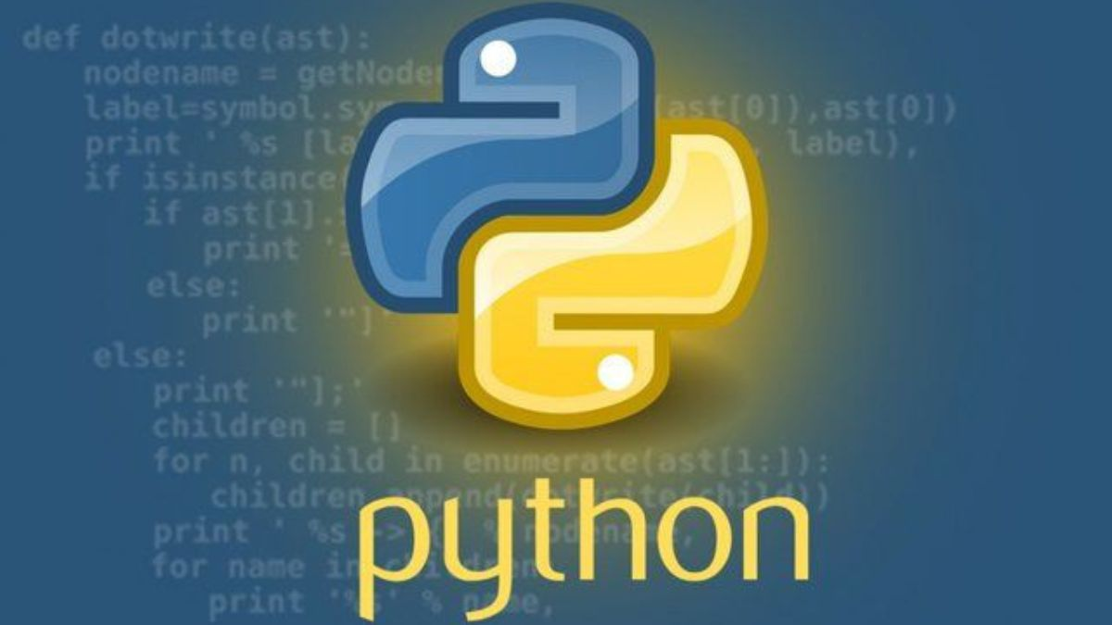

Results

The result of this project is that we created a Tic-Tac-Toe game using the programming language,Python.In this game, we compete with AI which uses the algorithms, Minimax and Alpha-Beta Pruning.The screenshots of the game running have been attached :-

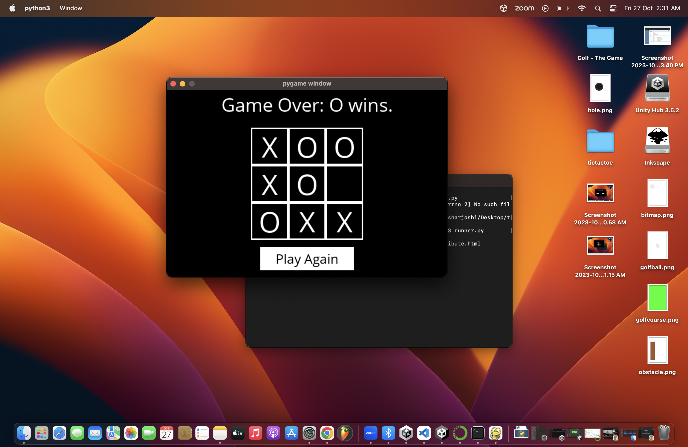

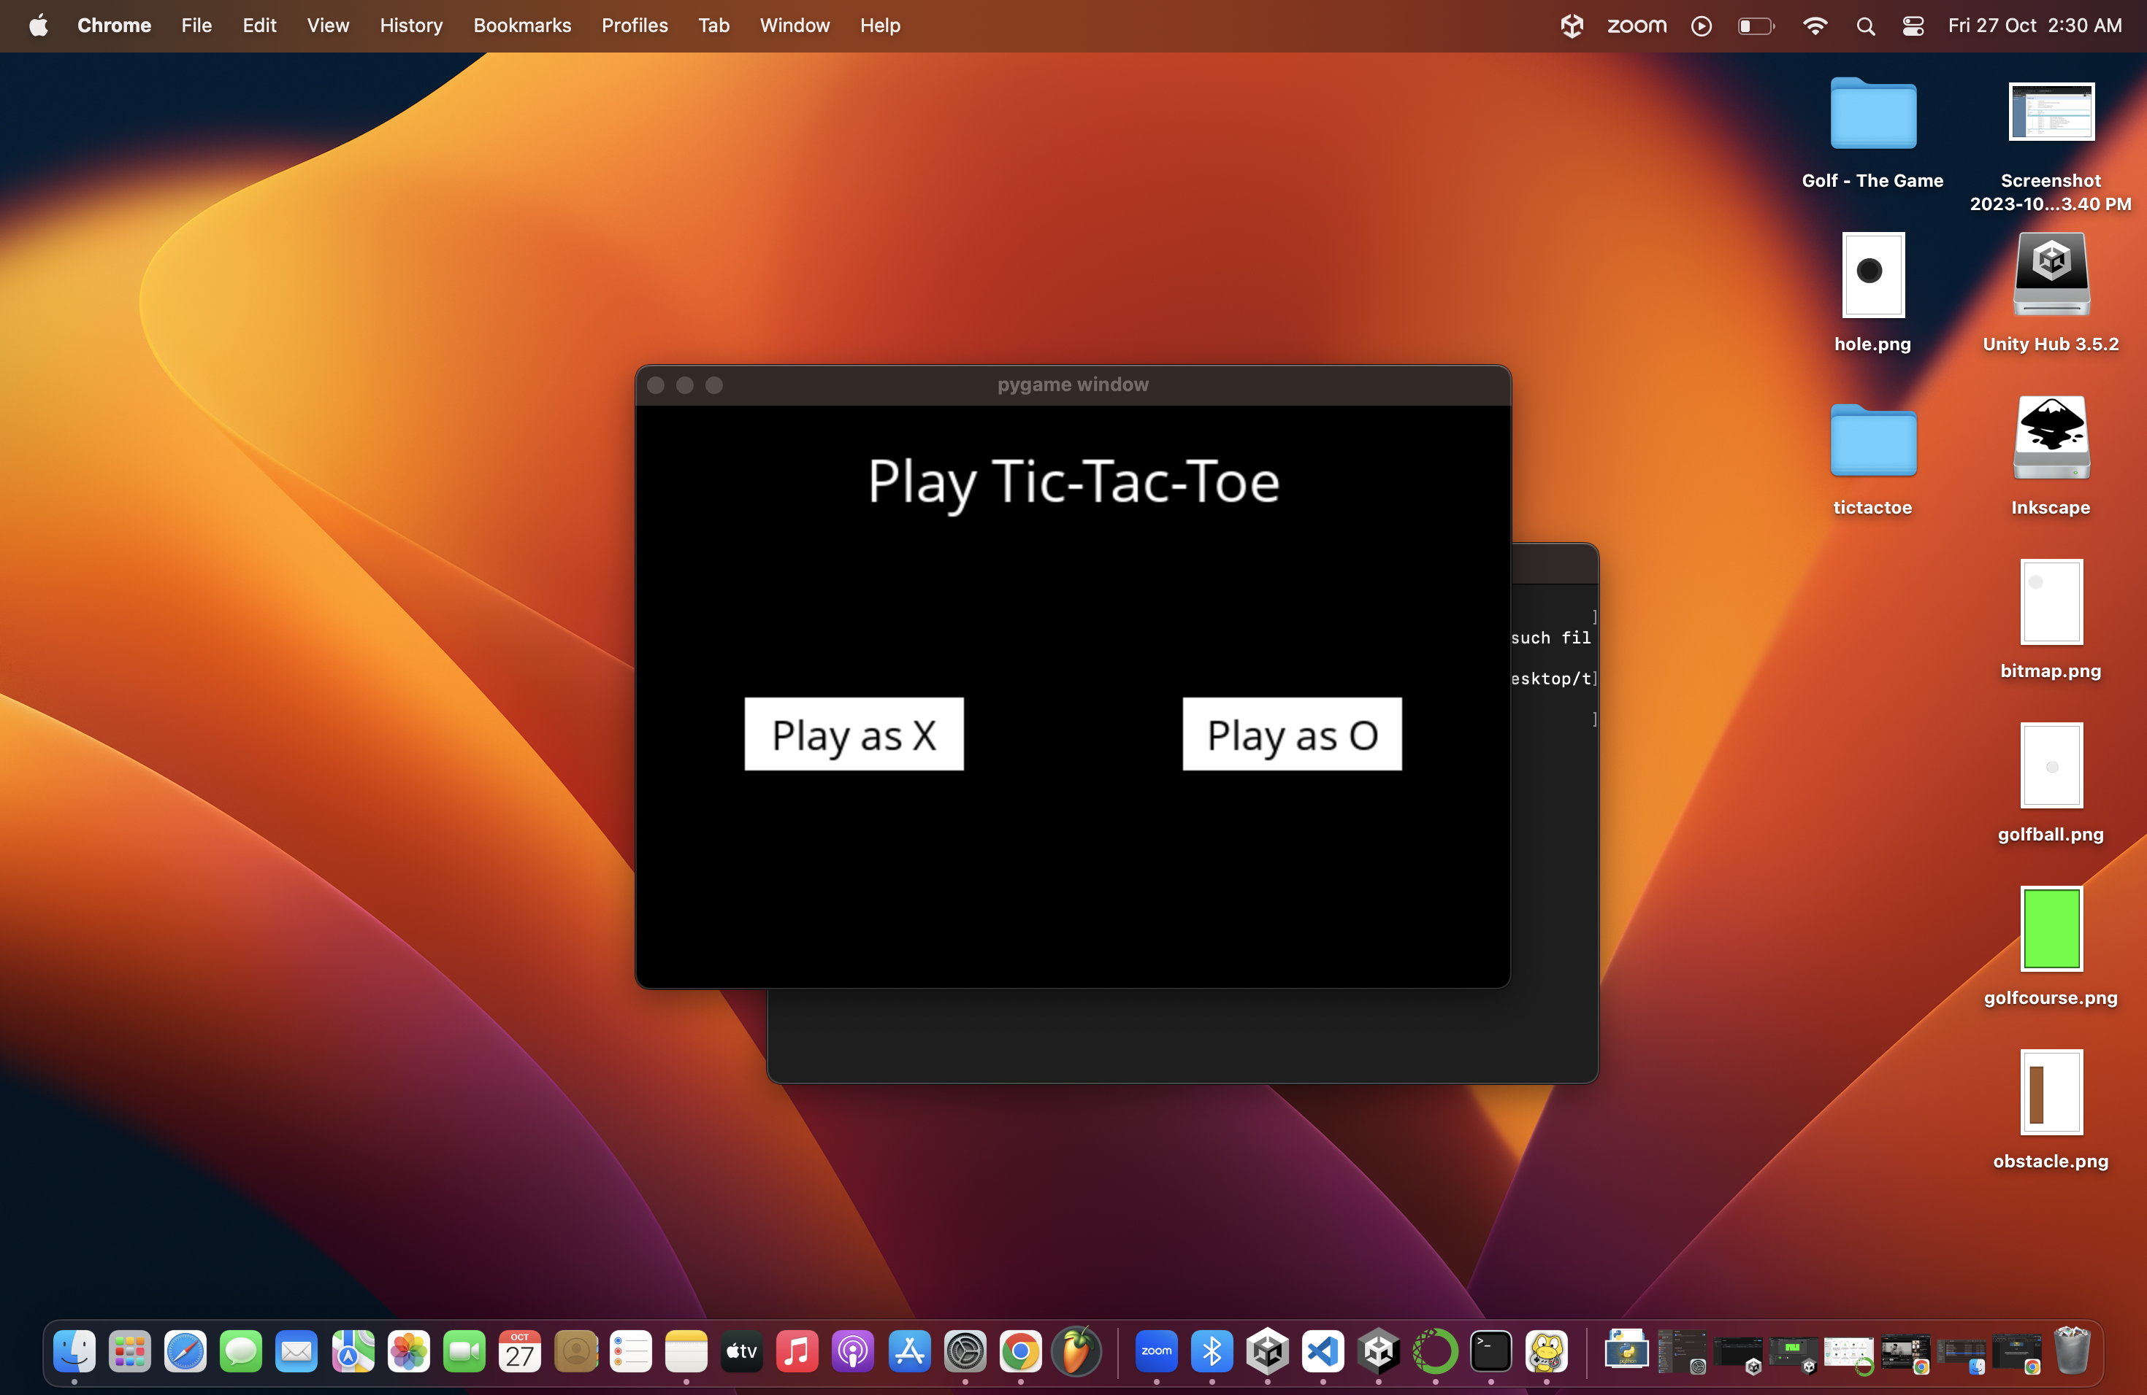

Conclusions

We can conclude that we completed the project of creating a game written in Python, the programming language.The name of the game created is Tic-Tac-Toe.In this version,we compete with AI which uses the algorithms, Minimax and Alpha-Beta Pruning to think and make moves.